Changing firmware: Onomondo Getting started device.

The device can easily be modified using the open source software from Arduino.

# Installing Arduino IDE

The software can be found [here](https://www.arduino.cc/en/software). Pick the appropriate version (e.g. ‘Windows’ or Mac OS X). Do not pick the *Windows app* option.

# Adding ESP-32 to Arduino.

There is an excellent guide [here](https://randomnerdtutorials.com/installing-the-esp32-board-in-arduino-ide-windows-instructions/).

# Get the source code

An updated version of the source code can be found [here](https://drive.google.com/file/d/112uLhNncnraAV9O0B1sWZRk09XIPoncw/view?usp=sharing).

# Open the project

Open the onomondo-esp32 file in the folder. The Arduino IDE should open.

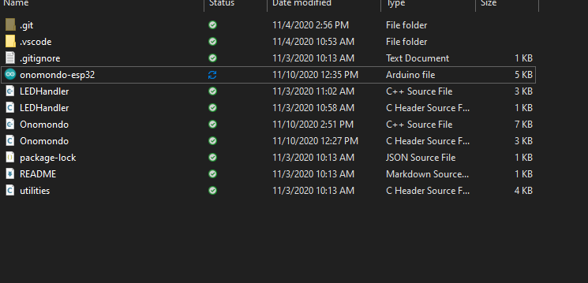

Under *Tools >> Board >> ESP32 Arduino* select *ESP32 Dev Module*

Under *Tools >> Port* select the correct port. In cases with multiple ports, the desired port can be identified by inspecting the list before and after the device is plugged in. Nothing can be broken by selecting the wrong port.

# Adding required libraries.

Some external libraries are used. To add these simply go to *Tools >> library manager.* Add the following libraries:

* ArduinoJson (by Benoit)
* TinyGSM (by Volodymyr)
* Ticker (by Stefan Staub)
* I2C Temperature Sensors derived from the LM75 (by Jeremy Cole)
* StreamDebugger (by Volodymyr)

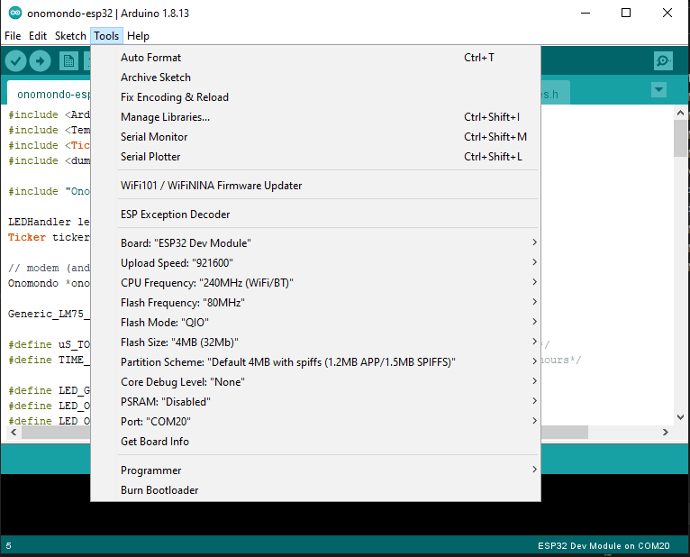

# Program the device.

Finally, the device should be programmed. This is done by clicking the small check mark.

If the upload fails: Make sure the device is connected, the selected com port is correct AND that you are not already connected to the board (e.g. already reading the debug outputs).